**Black Only Geometric Abstract Wall Art**

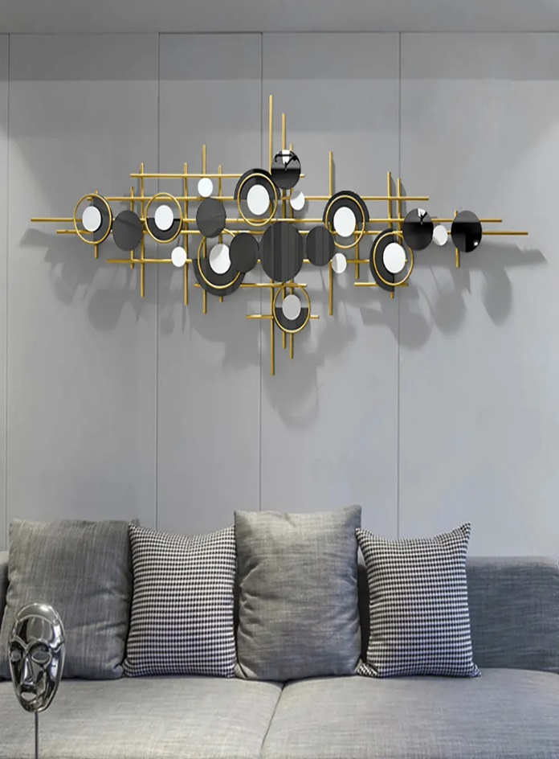Black-only geometric abstract wall art is a bold and minimalist statement piece that exudes modern elegance. Featuring sharp lines, intricate shapes, and layered patterns in a monochromatic black palette, it emphasizes texture, depth, and form. The absence of color enhances its versatility, allowing it to seamlessly complement various interior styles, from industrial to contemporary. Perfect for creating a dramatic focal point in living spaces, bedrooms, or offices, this artwork captures attention with its refined simplicity and sophisticated aesthetic. Its timeless design adds a touch of artistic edge to any space while maintaining a sense of understated luxury.